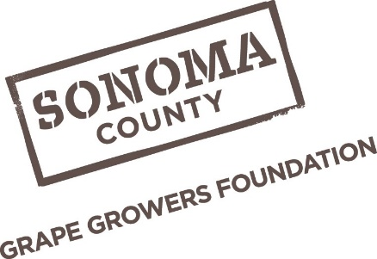
Sonoma County Grape Growers Foundation
400 Aviation Blvd., Suite 500 Santa Rosa, CA 95403
www.scggf.org

SCGGF Vineyard Employee Sustainability Recognition Program

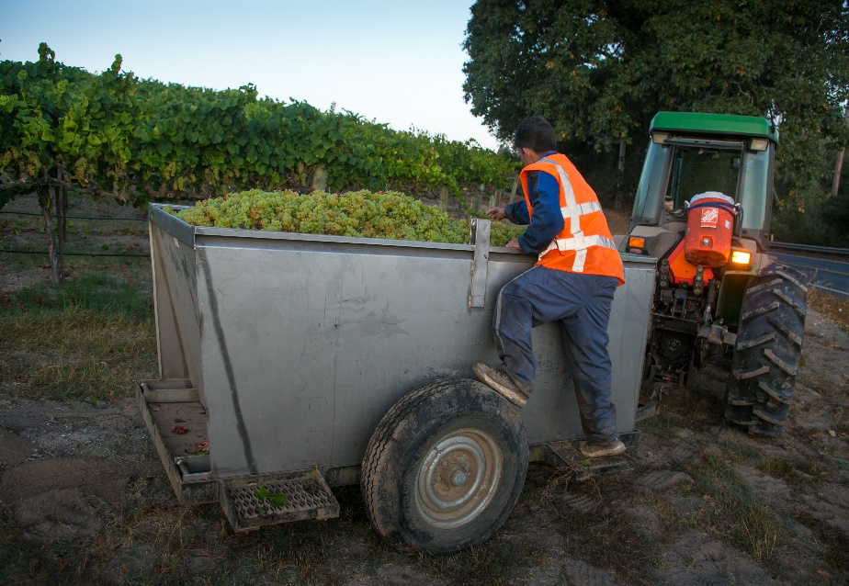
The Sonoma County Grape Growers Foundation (SCGGF) Vineyard Employee Sustainability Recognition Award is presented to vineyard employees who are achieving excellence in the workplace. Employees are recognized and rewarded for individual achievement and exceptional performance. Each month highlights a different theme, showcasing the various skills and numerous contributions of Sonoma County’s vineyard employees.

Nominations are accepted each month under the month’s specific theme (e.g. safety, leadership, pruning etc). SCGGF will select four vineyard employees every month for the SCGGF Vineyard Employee Sustainability Recognition Award.

Eligibility: Full time, part-time or seasonal employees working in agriculture for a vineyard owner, vineyard management company or winery are eligible for the Vineyard Employee Sustainability Recognition Award. Vineyard employees must be directly involved in the production of vineyards to participate in the program (e.g. Foreman, Field Worker etc). *Businesses may only nominate one employee per month*

Process: All nominations must be submitted by the 10th of the month following the month of the award. (i.e. February applications are due March 10th). Nominations should be submitted to info@scggf.org.

Recognition: Recognition of all recipients will occur throughout the year. A quarterly advertisement will be placed in the Press Democrat or local Spanish newspaper(s) recognizing all employees selected that quarter. An announcement will also be made on the local radio during KSRO’s The Drive with Steve Jaxon. Recipients of the award will receive gifts in the form of gift cards and clothing. At the conclusion of each year, SCGGF will host an award luncheon for all award recipients, their employers and family members.

